In Memory of Phra Phillip Ṭhānavuḍḍho - Phillip Allen Dale Jr.

It is with deepest regret that we announce the passing of Venerable Phra Phillip Thanavuddho (Phillip Allen Dale JR born November 8, 1978). He joined the Temple in April 2018 coming from Wat Samakki in Arizona after recovering from an illness. Phra Ajahn Phillip was a diligent and dedicated monk, an asset to the Temple for his Dhamma knowledge and talks in English. His departure was sudden, unexpected, and came as a great shock to all of us. We wish to pause and pay our respects in memory of his lifelong services and inspiration to those around him.
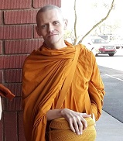
With Metta,
ABM Board and Monks

