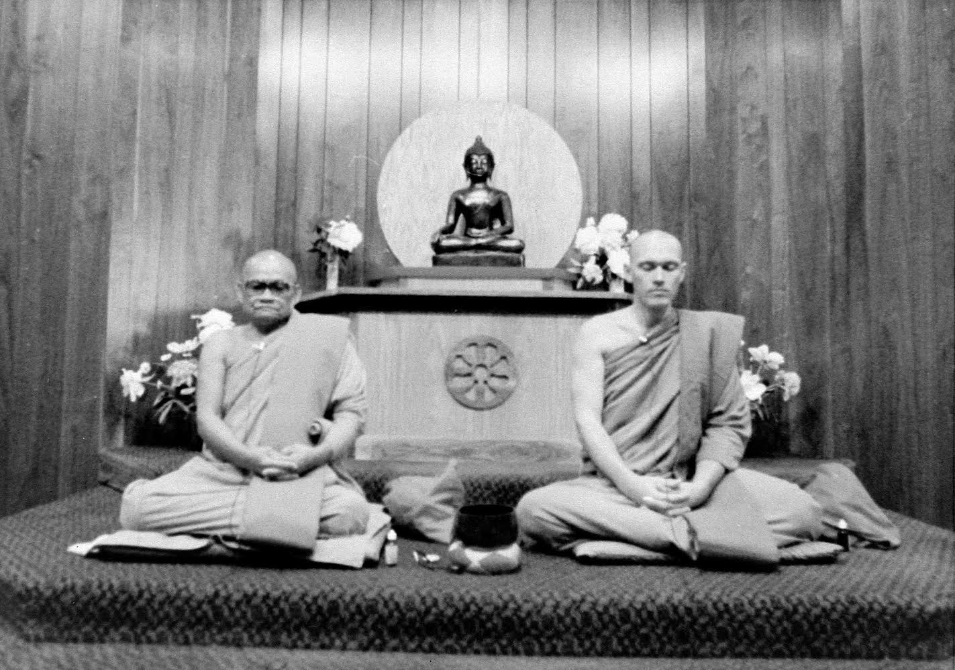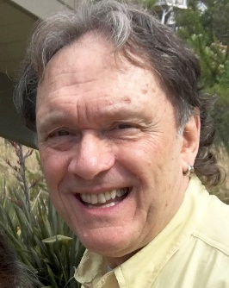

“*Realizing Dhamma in Daily Life: A Noble Resolution*” – Thursday Dhamma Talk followed by ‘Two Day Long Retreats’ with Joseph Kappel (see details below)

Ajahn Chah and Pabhakaro Bhikkhu at IMS in Barre, MA. June 1979

**Dhamma Talk** “Realizing Dhamma in Daily Life: A Noble Resolution” Thursday 10/18

From 1971-1991 ***JOSEPH KAPPEL*** lived as a Buddhist monk as **Pabhakaro Bhikkhu**, with **Ajahn Chah** and **Ajahn Sumedho** in Thailand and Great Britain. His initial interest in Buddhism was inspired by visits to Thailand from Vietnam where he was a Captain serving as a combat helicopter pilot in 1969-70.

Since leaving monastic life in 1991, Joseph has taught *MBSR (Mindfulness Based Stress Reduction)* in Massachusetts’s prisons, received *the degree of Master of Education from Harvard University*, and worked with college athletes to facilitate “mental fitness” and the inner game. He currently teaches meditation retreats in various settings in the US. Additionally, he co-leads retreats with **Ajahn Amaro** at Amaravati Buddhist Monastery in England.

He returns to his native Seattle to offer his life perspective influenced by almost 50 years of Buddhist practice. He communicates from the unique perspective of combat missions of destruction in Vietnam, to seeking the inner peace of a contemplative monk in the jungles of Thailand. The two-independent day-long offerings at Wat Atammayatarama will be a chance to learn how aspects of Buddhist contemplation offers something for everyone. You’re invited to attend any or all of the events.

Joseph’s commitment is to encourage everyone to awaken in daily life by using life’s journey to cultivate deep understanding, virtuous conduct, along with wise effort & reflection. Joseph and his wife Catherine live in Leominster, Massachusetts.

At Wat Atammayatarama in Woodinville led by Joseph Kappel:   **Thursday** evening, 10/18 7-9 pm. Chanting and Meditation with Thai Monks followed by a Dhamma Talk by Joseph. Two Non-Residential Retreats: **Friday:** October 19th 9:00am to 4:30pm. *AND* **Saturday:**October 20thsame time frame. Lunch is provided by the generosity of the Thai Buddhists and there is no fee involved for the Retreats. However, donations are welcome. **Please register for the Retreats at**[**www.atamma.org**](http://www.atamma.org/) for questions about the Retreat email [info@atamma.org](mailto:info@atamma.org).